Permissions

As an author, you are required to secure permission to reproduce any copyrighted material, which includes the following:

Text | Fair dealing advice | Useful websites
Prose/poetry/song lyrics | Clear all usage
Newspapers/magazines/journal articles | Over 50 words
Books | Anything over 300 words | www.copyright.com (for US permissions)
Epigraphs | Clear all usage | Original publisher
UK Government papers/publications | Use ‘click-use’ licences | www.opsi.gov.uk
UK Ordnance Survey maps/redrawn maps | Clear all usage | www.ordnancesurvey.co.uk/oswebsite
Digital/internet material | Anything over 50 words
Film stills | Clear all usage
Artwork/paintings/illustrations | Clear all usage | www.dacs.org.uk  http://www.arsny.com
NB. It is not possible to copyright ideas, procedures and systems, facts, basic plots, or thematic concepts.

Author’s Responsibilities

It is your responsibility to obtain permission by writing to the publisher or owner of the material in which the quoted material appears. It is the publisher, not the author, who is usually empowered to grant permission on behalf of the copyright-holder. This also applies to re-using your own published work – you still usually require permission from your original publisher.
If permission fees are charged, it is your responsibility as the author, editor or contributor to pay the costs unless you have made an alternative arrangement with your commissioning editor.
All permissions must be cleared by the time the typescript is ready for delivery. Seeking permissions can be time-consuming, so please start the process off as soon as you use material in your book which will need permission.
Please note that epigraphs are automatically counted as embellishment of the text, and permission must be sought for their use (this will usually involve emailing the original publisher of the quoted work with your chapter, so that they can view the content in context).

Principles of Copyright

The basic principles of copyright are the same throughout the world, but there are some significant differences between the UK and Europe, and the US. In seeking permission, you must follow the permissions guidance for the territory(ies) in which your book will be published. If your book will be published in more than one territory we recommend that you follow the guidance of the territory which is the most restrictive.

In the UK and the European Union:
- Copyright held by the author: works are protected for 70 years from the end of the year in which the author died.
- Copyright held by the publisher: works are protected for 70 years from the end of the year in which the work was first published.
- Unknown authorship: works are protected for 70 years from the end of the year in which the work was first published.
- Crown copyright applies to all works published by the British Government. Material can usually be reproduced free of charge for purposes of analysis and commentary if it is fully acknowledged, but use of such material in commercial publications must be sought from HMSO. Two convenient ‘click-use’ licenses are now available from their website –www.opsi.gov.uk/click-use/index.htm.

In the US:
(Copyright protection is more complex in the US.)
- Works published before 1 January 1923 are protected for 75 years from the date copyright was first secured.
- Works published from 1 January 1923 to January 1964 were required to have copyright renewed during the 28th year of their first term of copyright, which then covered them for 95 years from first publication.
- Works published 1 January 1964 to 31 December 1977 are protected for 95 years with no need of renewal.
- Copyrights in their second term of protection from 1 January 1978 automatically have the full 95 year period of protection without requiring renewal.
- There is a list of more specific rules (all eight of them) available on the Gutenberg website (details below).
- Works published prior to 1906 or published by the US Government are in the public domain and require no permission to quote.
Please note that copyright is a territorial right, therefore what protection exists is determined on a national basis. However each work is considered to have a country of origin irrespective of the nationality of the work’s author, which will be the country in which the book is first published or in the case of works published simultaneously in several countries which grant different terms of protection, the country whose legislation grants the shortest term of protection.

Do you always need permission to reproduce text quotations from other sources?

UK-origin text
In the UK under a convention known as ‘fair dealing’, permission need not be sought for short extracts if they are used for the following purposes:
- non commercial research
- private study
- the content is quoted in the context of ‘criticism or review’ and news reporting (and is not merely used as decoration)
- the purpose is for educational/ academic research
It is important to bear in mind that fair dealing is not a legal right or principle – it is a defence against a charge that you have infringed someone else’s copyright, so if in doubt, we would urge you to seek permission.
Even if permission is not required, you should fully acknowledge the source of all your quotes.

In the case of longer extracts, the author’s permission as well as the publisher’s may be required. If the material comes from an out-of-date book, the author may not wish it to be reprinted. He or she should also be asked to approve any changes you wish to make to their material, such as making cuts. If you want to translate any material, you will need to get permission from the original language publisher and they often prefer you to use an approved existing translation. Getting permission to re-translate an author like Brecht, for example, can be a lengthy and frustrating business.

The general rule is: if in doubt, seek permission.

US-origin text
In the US, ‘fair use’ is a common sense doctrine that allows for a certain amount of material to be reprinted without permission. The amount of material that falls into the ‘fair use’ category is undefined, and indefinable, and relies to a large extent on your judgement. We suggest using the following criteria to help you decide when to apply ‘fair use’ and when to request permission:
- Will your use of the material compete directly with the source publication?
- Is the material a complete section/selection from the source? E.g. a complete chapter from a book, a complete poem, a complete scene from a play?
- What is the proportion of the extract to the whole of its source? 400 words from a 4000 word article would require permission; 400 words from a 100,000 word book, probably not.
- Does your proposed 400 word quotation represent the copyright holder’s central idea or thesis? (E.g. the last sentence of Scott Fizgerald’s The Great Gatsby is only 14 words, but because it is exceptionally well known, it would not fall under ‘fair use’).
If the answer to any of these is yes, then permission should be sought.
It is important to bear in mind that fair use is not a legal right or principle– it is a defence against a charge that you have infringed someone else’s copyright, and it rests on the integrity and good faith of both authors and publishers. The US courts consider four basic criteria when deciding cases of infringement:
- The purpose and character of the use, including whether the use is commercial, or non-profit and educational.
- The nature of the copyrighted work – is it primarily informational and factual, or entertaining and fictional?
- The amount of the quote used in relation to the size of the whole work.
- The effect of the use on the potential market for, or value of the copyrighted work.
A good rule of thumb is to ask yourself how you would feel if this were your material being reprinted?
The general rule is: if in doubt, seek permission.

Permissions Guidance for Legal Materials

UK law: using cases
The majority of case reports fail to qualify for copyright protection as they are simply reciting the facts, and lack sufficient originality of expression. Once presented in court, a case enters the public domain and is therefore free to use.
However, if the case you wish to cite has been extracted from a reporting service such as Lexis Nexis, WestLaw or Justis, any headnotes or commentary on the case will qualify for copyright protection and will be subject to clearance.

UK law: acts of parliament
All legislation and statutory instruments will be Crown copyright and permission to reproduce is free of charge, subject to an Open Government Licence. You must acknowledge the source of the information by including any attribution statement specified by the Information Provider(s) and, where possible, provide a link to this licence: http://www.nationalarchives.gov.uk/doc/open-government-licence/.

European legal materials
European Court reports and judgments, treaties and regulations reproduced from Eur-Lex can be used free of charge, except where otherwise stated, provided appropriate acknowledgement is given as follows: ‘© European Union, http://eur-lex.europa.eu/’. When legislation proper is reused, the following disclaimer shall be added: ‘Only European Union legislation printed in the paper edition of the Official Journal of the European Union is deemed authentic’.
Judgments reproduced from Curia can be used free of charge provided the source is acknowledged. However, certain parts of such information and texts might be protected by copyright, so you will need to check.

Legal journals
As with any other journal, legal journal articles, whether published in print or online, are subject to copyright and permission to reproduce must be cleared with the copyright holder.

Notes to Bear in Mind

Poetry
- Some poets will not allow changes to the layout of the poem. Poem fees are charged by line.

Song lyrics
- You may be charged the same price for one line as for an entire song. Rights holders for song lyrics require people intending to reproduce lyrics to apply for permission for each re-use and a fee may be charged.

Illustrations
- Works of Art – although classic paintings and works of art are often in themselves out of copyright, museums and art galleries usually copyright all photographs or slides taken
of them.
- If the artist died more than 70 years ago, the work of art will be in the public domain.
- If the artist died less than 70 years ago, or is still living, then you need to ask permission of the artist or their estate.
- If the art is owned by a private individual, you will need to seek their permission.
- If the painting is on display in a gallery or museum then you need to ask the gallery owner’s permission.
- You may be asked for two fees: one for permission and one for supplying a print.

Photographs
- If the photograph appears in a book, approach the publisher for permission, unless the photographer is acknowledged as the source, in which case approach the photographer directly.
- Photographs from picture agencies usually only require their permission.
- Be careful about cropping photographs or changing the colour as this affects the owner’s moral integrity.
- If you want to use a photograph of an individual, you should seek their permission as well as that of the photographer.

Adverts
- If you wish to reproduce advertisements, both the company owning the product
and the advertising agency should be approached for permission.

Tables
- Information cannot be copyrighted, so you can use raw data to construct your own table, but if you use the layout, format and selection of data of the original, you must clear permission.
- If you add or delete rows or columns of data you should acknowledge the
original source (‘Adapted from...’), but formal permission is not necessary.
- If the content of the table is unchanged, you should seek permission to reproduce.

Redrawn artwork
- If different from the original you should still acknowledge the original source in the caption (‘Adapted from...’).
- If a comparison between your own interpretation and the original does not show obvious
differences, permission to reproduce must be sought.

Digital material
All on-screen digitized material is subject to the same copyright restrictions as the printed page and permission to use it must be obtained from the copyright-holder in the normal way.

The Internet
Copyright protection also applies to material displayed on the Internet. Apply for permission as for printed material; check the copyright notice on the web page and send a permission request by e-mail to the website operator. In a single website there may be more than one copyright-holder and the consent of each will probably be required. We urge you to exercise caution with any image downloaded from the Internet, e.g. from Wikipedia, Google, or Facebook, where images are frequently posted without the knowledge or permission of the copyright holder, and are quickly removed if the copyright holder raises an objection.

Film stills
Permission should be sought for reproducing all film and TV stills.

Third party software
Any software used in a DVD or on a web page must have the rights cleared.

New editions
Permissions secured for text or illustrations in a previous edition cannot be used in new editions, and permission must be cleared again.

Authors' Licensing and Collecting Society Limited UK (ALCS)
All books/magazines/journal articles should be registered with ALCS in order to receive copyright licensing royalties. Even though you may not be a member, ALCS might still be holding royalties for you. You can check using a 'search for royalties' facility on their website. If you would like to join please visit www.alcs.co.uk or call ALCS on 020 7264 5700. Authors of any nationality can register.

Making Your Application

For Books published in the UK
In most cases you will need to request permission for world rights in all languages. If you exceed the fair dealing limits, you will probably be charged a fee, which will be based on the number of words you wish to quote, so make sure the number is always included in your application. You should also say whether your book will be hardback or paperback, and give its expected price, year of publication and the number of copies to be printed. You should also request permission to publish the material in eBook format, since, with very few exceptions, all of our titles are published simultaneously as eBooks. Check these details with your editor, who will also advise you on how to deal with any fees that seem too high, or any other difficulties.

A specimen permissions letter is shown below. It is a good idea to include a photocopy of the original material (text or illustration) with your request.

When you deliver the final typescript, you should include with it all permissions correspondence (keeping a copy for yourself), with details of any items that have not been cleared. Your typescript should include an acknowledgements page, in which you follow any specific wording requested by the publisher/copyright-holder.

Please note that Taylor & Francis controls the rights in backlist titles previously published by Allen & Unwin, Architectural Press, Butterworth-Heinemann UK, Cavendish Press, Croom Helm, David Fulton, E & FN Spon, Earthscan, Falmer Press, Methuen & Co. (the academic list), Routledge, Routledge & Kegan Paul, RoutledgeCurzon, RoutledgeFalmer, Spon Press, Tavistock Publications, UCL Press and Willan. Note that you still need to apply for permission to reproduce material published under these imprints.

Specimen Permission Letter for text

Dear Permissions Manager,

I am preparing an academic book entitled [book title] which will be published by [imprint] in [year]. It will be published in [hardback/paperback] and is expected to cost [price]. The print run will be [number] copies. The material will also be produced in eBook format as a verbatim digital copy
of the printed work (i.e. it will be used in exactly the same context as the printed version, and without alteration). In eBook format the cost will be [the same price as the hardback (if HB only); the same price as the paperback (if dual edition)].

I would like your permission to include the following material from one of your publications.

Title

Year of publication

Author/editor

Page number(s) and total number of words and/or Figure/Table number

I understand that you control the rights to this material. I would be very grateful if you could grant permission for its use as soon as possible, stating any credit lines or fees that you require. If you do not control these rights, please let me know to whom I should apply.

We are seeking non-exclusive world English language rights and will reproduce the material as part of the complete text in print and electronic formats for distribution throughout the world.

Yours faithfully,

For Books published in the US
We suggest you make your request through www.copyright.com . Titles and usage may be selected there as follows:
- Type your ISBN/Title of the requested work in the search box on the opening page.
- Select the title from which you would like to use partial material.
- Select ‘Republish or display content’ – the last choice in this menu below:
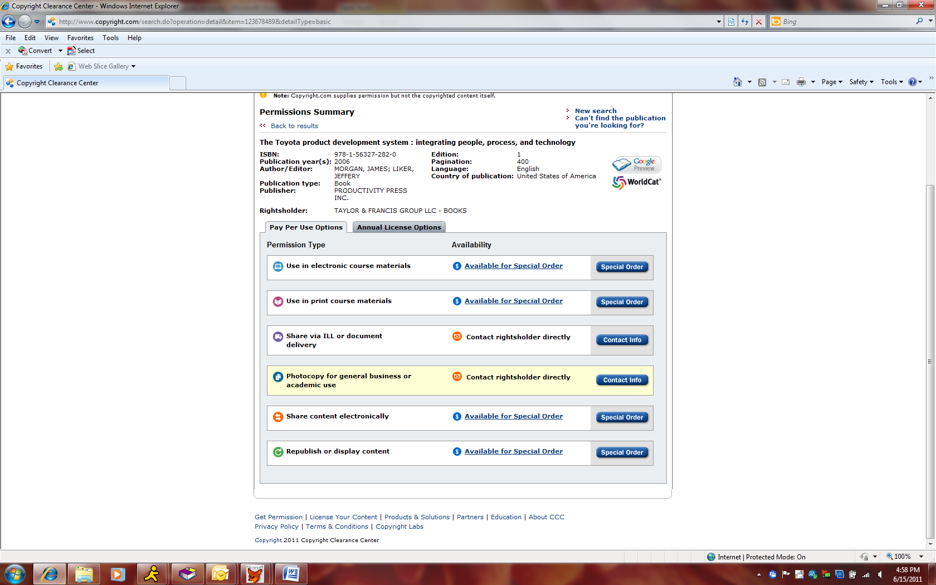
- Then fill out the form below:

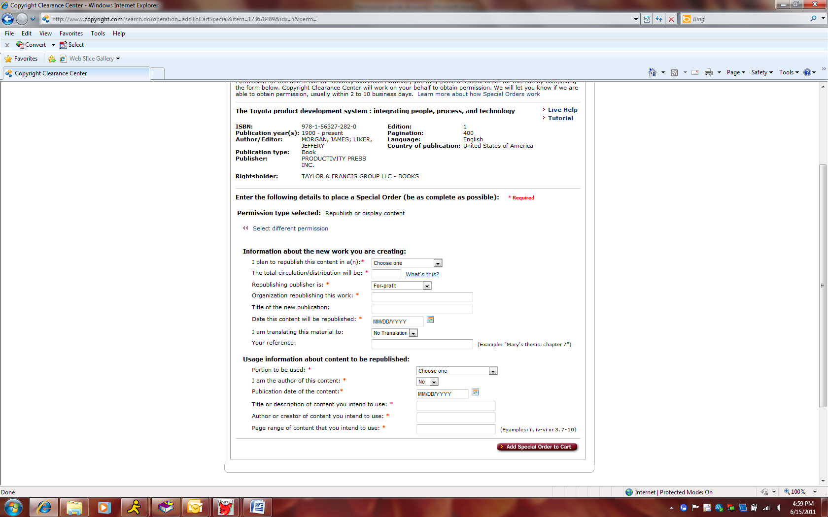

- Make sure to fill in all applicable fields, including planned print run and page amount and if you are the author of the material. For electronic rights use the ‘other book’ option.
- Click ‘Add Special Order to Cart’.
- Make sure that when you reach the last step, you ‘create a new user account’.
- Click ‘check out’ in your shopping cart and receive an ‘Order #’.

If you are requesting material from another Taylor & Francis publication, or if you are the author of the requested material, your request is likely to be granted gratis. Copyright Clearance Center charges a small transactional fee of $3 for processing the order, but it means your request will be handled more quickly and efficiently.

To request permission to use material from a US book in a course or business program
- Type the ISBN/Title of the requested work in the search box on the opening page.
- Select the title from which you would like to use partial material.

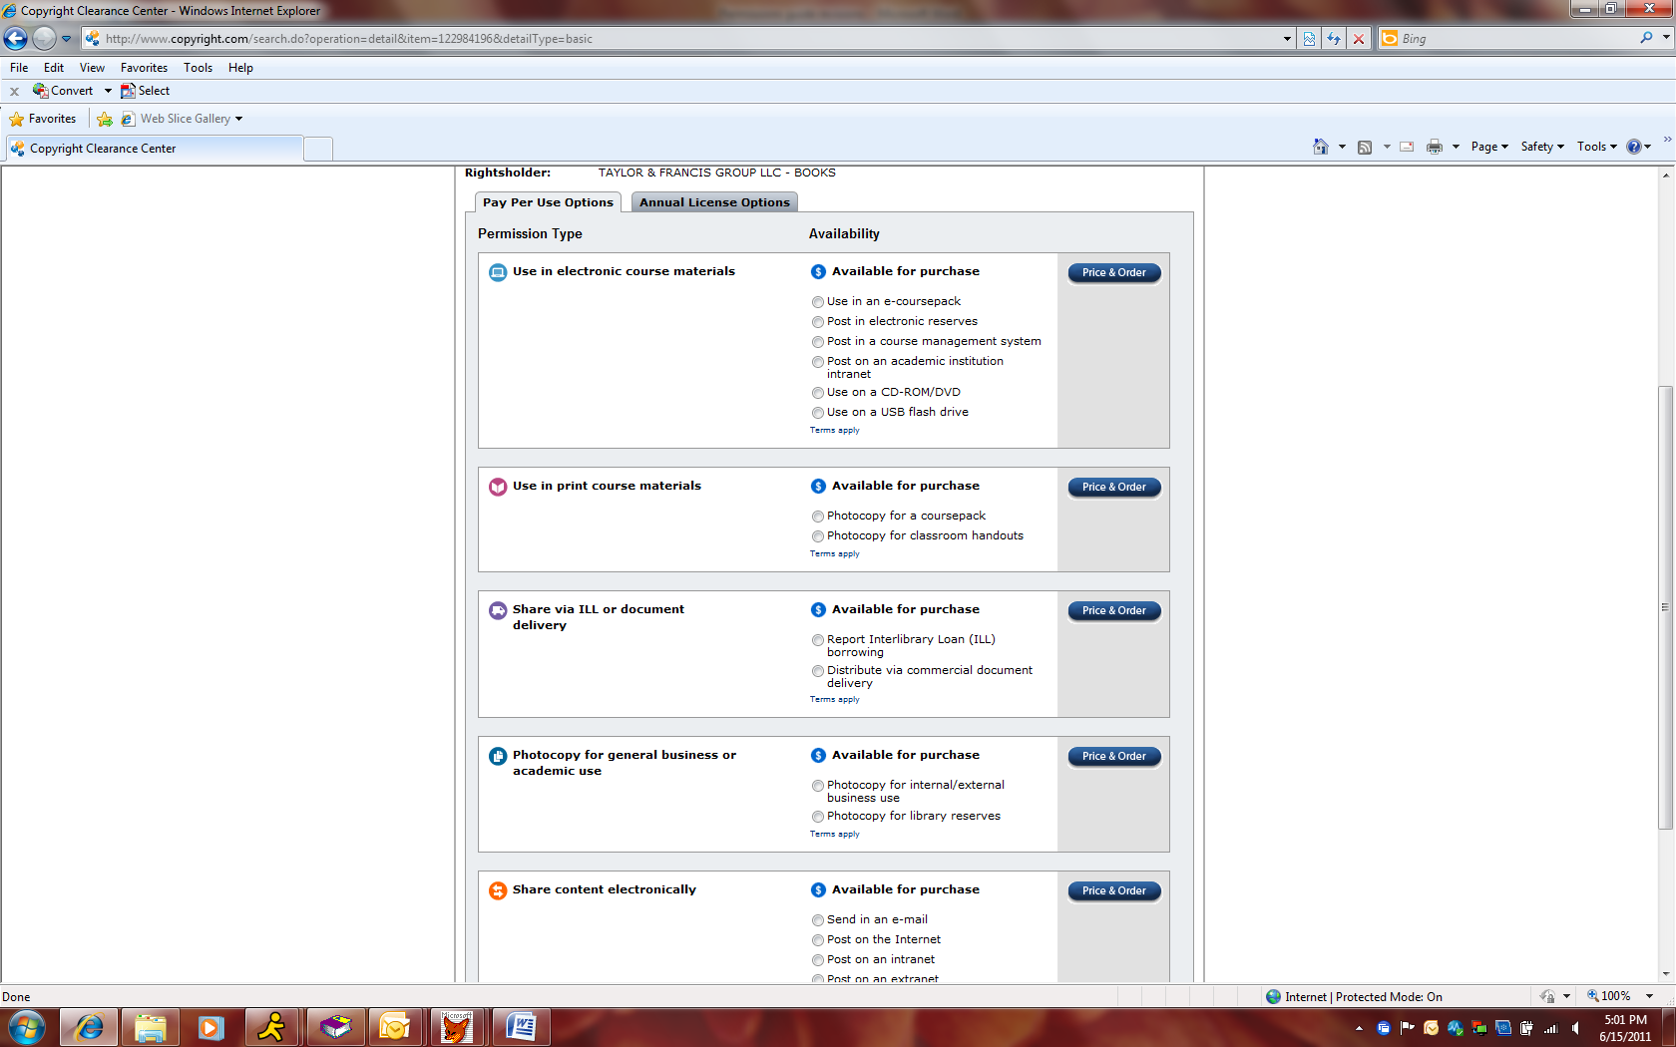

Frequently Asked Questions
Do I need permission if I use material from my own work?
Yes, you will need to check who owns the copyright of the original work, and ask for permission to reuse the material. The original publisher will usually give you permission to reproduce your own work free of charge. If a license was agreed with the publisher in the first instance then permission will again be granted for free.
Do I need permission if I work for the company whose image I am using?
Yes, you will need to check who owns the copyright (this may be the publisher, author, institution, or organization), and ask for permission to reuse the material.
Do I need permission to use an image from Google Earth?
Please see www.google.com/permissions/geoguidelines.html.
Do I need permission to use a picture that includes other people or a proprietary object?
Yes, you would need permission for both.
Do I need permission if I use a Facebook screenshot?
Facebook screenshots may be used according to their guidelines but you will need prior written permission from Facebook.
Do I need permission to use an image from Flickr?
Yes. Flickr images may fall under a common usage license or may have all rights reserved.
Do I need permission to use an image from Yahoo?
If you are seeking permission to use any Yahoo! UK trademarks, logos, screen shots, copyrighted designs, or other brand features from the Yahoo! UK websites, please see http://uk.docs.yahoo.com/copyright.html.
Do I need permission to use a Crown copyright image?
Please see www.nationalarchives.gov.uk/legal/copyright.htm for further guidance.
Do I need permission to use a Google N-Gram?
No, but please make sure that you cite: Jean-Baptiste Michel, Yuan Kui Shen, Aviva Presser Aiden, Adrian Veres, Matthew K. Gray, The Google Books Team, Joseph P. Pickett, Dale Hoiberg, Dan Clancy, Peter Norvig, Jon Orwant, Steven Pinker, Martin A. Nowak, and Erez Lieberman Aiden (2010) ‘Quantitative analysis of culture using millions of digitized books’. Science. Published Online Ahead of Print: 12/16/2010. DOI: 10.1126/science.1199644 www.sciencemag.org/content/early/2010/12/15/science.1199644 .
Do I need permission to use ClipArt?
Yes. The use of all Microsoft copyrighted content is subject to permission being given by Microsoft – see www.microsoft.com/About/Legal/EN/US/IntellectualProperty/Permissions/Default.aspx#ELC. Commercial reuse (for example, in an academic journal) may be prohibited.
What is the STM Agreement and how does it affect me with regard to seeking permissions?
Taylor & Francis is a member of the International Association of Scientific, Technical and Medical Publishers (STM), and since 1979, signatory to the STM Permission Guidelines on the free and reciprocal exchange of text, figures, and tables. The guidelines state that ‘requests for small portions of text and a limited number of illustrations should be granted on a gratis basis for signatory participants, and further describe a more automatic process which eliminates the need for requests to be transmitted (some signatories have chosen this route, others continue to request express permission requests). The guidelines apply to both book and journal content, and facilitate reproduction of further editions or in other media such as in online form’. The guidelines and list of participating publishers is at: www.stm-assoc.org/permissions-guidelines/.
Further resources
The US copyright office website contains really useful copyright information, and you can check if the material you require has had its copyright renewed or not: http://www.copyright.gov
This website gives more helpful information about finding copyright holders: http://tyler.hrc.utexas.edu/uk.cfm
To find out if a work is in the public domain (out of print and out of copyright), see: www.gutenberg.org/catalog
The Watch file – database for copyright contacts for authors and artists: www.tyler.hrc.utexas.edu/index.cfm
Copac – this site catalogues the history of a published work. You can search by author or title: www.copac.ac.uk
Copyright permission fact sheet from UK Copyright Service.
Copyright Law: Understanding Fair Use fact sheet from UK Copyright Service.
UK Publishers’ addresses can be found at www.ukpublishers.net a site run by the UK Publishers Association, and in The Writers’ and Artists’ Yearbook published by A&C Black, or from the publisher’s own website.
US Publishers can be found in Literary Market Place – most libraries have a copy of this publication, which comes in two versions, one covering the USA, and one covering international publishers.

.

